





















Numentica’s response to FEDBANK FINANCIAL SERVICES LIMITED

Response for

DATA ANALYTICS PLATFORM MODERNIZATION PROJECT



Contents
1. Executive Summary 3
2. About Numentica 3
3. Project Scope 3
3.1. Current Data Flow Process in Datalake 3
3.2. Key Challenges within the Existing System Landscape 3
3.3. Limitations of the Current Datalake Architecture 5
4. Numentica’s Solution 5
4.1. Proposed Architecture 5
4.2. Mitigation of Present Challenges 5
4.3. Business Benefits 5
4.4. Further Recommendations for Optimal State Architecture 6
4.5. Technology Criteria & Recommendation 6
5. Detailed Commercials 6

- Executive Summary

- About Numentica

- Project Scope

  - Current Data Flow Process in Datalake

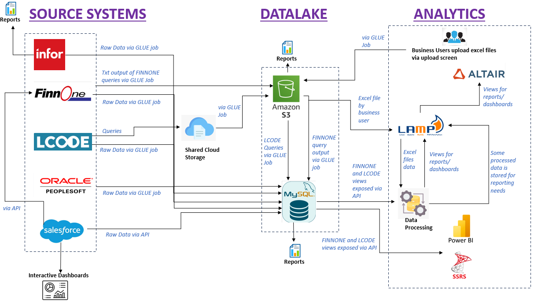

  - Key Challenges within the Existing System Landscape

1) Not all DBs are integrated in datalake.
e.g. they have a file tracking system which has information about what loans are disbursed and that is sent to some agency. They don’t have any reporting requirements for this hence it is not brought to datalake.
e.g. Digital team has separate DBs for Vendor Management System, Lead Management System, Legal, ERM (Internal software for enquiries), app/website. These are small tables hence not yet moved to datalake.
2) Primary Key-Reference key column names are different between tables in Finnone. This is because of how Finnone source system sends the data. So, unless someone knows the Finnone system it is difficult to understand the relationship between tables.
3) Even though all raw tables are fetched in datalake for Finnone and Lcode, still the source system is hit to generate dumps which are used by analytics team to for reporting in Altair. This is because it is difficult for Analytics team to understand the structure of core system tables AND not all columns from raw tables are important for their reports.
4) Datalake tables do not have indexing (only some tables have as per need basis). Source system Finnone and Lcode have indexing.
5) Frequent changes in the queries from Finnone and Lcode because of change in business requirements. Adhoc reports during audit time are also needed. This involves dependency on source system.
6) For LCODE, the Fedfina team does not have direct access to source system. They pass on the BRD to LCODE vendor and are completely dependent on the vendor to create query.
7) Additional overhead for Analytics team to maintain the Lampstack DB.
Some business users provide data like budget files, HR related files using upload option. For these separate tables are created in Lampstack DB.
Additional data processing is done by Analytics team on top of the views exposed via datalake like merging of some dumps, logic creation. All this happens in MYSQL workbench of Lampstack DB.
For any trend analysis reports where past data is required, Lampstack DB is used for storage of old data.
8) Data issues in the views exposed from datalake to Analytics team. This is mainly due to incorrect queries written by source systems while generating dumps.
9) Issues while reading data from Datalake to Altair. This is due to JDBC connector issue.
10) Changes and new report requests from Altair are very common. Everytime they have a dependency on IT team to provision that data in datalake first before they can do further processing to generate the required report.
11) Currently reports are generated from S3, Datalake views, ALTAIR, Power BI, SSRS both manually and automatically. There is no centralized system and process for reporting. Everything should be done from Altair.
Additional Opportunities of Automation/Optimization
1) Etouch schema in datalake is a customer servicing system. Dashboards created from etouch schema are sent via email. NOT AUTOMATED THROUGH ALTAIR.
2) Fedfina bureau schema in datalake holds cibil related information. Risk analysis reports are created from this system on need basis by running queries. NOT AUTOMATED THROUGH ALTAIR.
3) Interactive dashboards are generated from Salesforce source system directly. They want to do that from Datalake.
4) SSRS and Power BI are also used for reporting. Everything should move to Altair (already in plan)
5) AL and ML models to be built for advanced analytics in reports (already in plan)

  - Limitations of the Current Datalake Architecture

We should be covering below points for this section:
- Is it even correct to call their existing system as a datalake?
- How is it not an ideal datalake architecture? Compare with other NBFCs how they are designing their datalake.
- What is the impact Fedfina will have by not having an ideal datalake architecture?
- What is Fedfina losing by not having Data Governance setup?

- Numentica’s Solution

  - Proposed Architecture

  - Mitigation of Present Challenges

Have to mention how the proposed architecture solves each of the above mentioned challenges.

  - Business Benefits

For all the challenges that will be solved by Numentica’s solution, what would be the business benefit e.g. increase in customer acquisition rate, customer retention, marketing would improve, data-driven decision making etc.

  - Further Recommendations for Optimal State Architecture

Data Governance can be part of this section.

  - Technology Criteria & Recommendation

All the AWS services as part of the proposed architecture can be described here with its use and benefits.
If we are planning to recommend anything other than AWS then a comparative study can be put here.

- Detailed Commercials

It will be a T&M based contract.

Additional information as requested –

- No. of queries and its complexity for each dashboard
Depends on the report requirement. Majorly merging of views like views having risk data is merged with views having HR data AND logic implementation like how much old data is needed, department level filteration, product level filteration etc.
Complexity of queries – Medium
- Data volume
Depends on how much old data is required by the department in which report. As of now one of the risk reports have Maximum data volume of 30-40 lakh.
- No. of dashboards
4-5 Power BI reports are moved to Altair that take around 2-3 hours to prepare.
60-70 management reports go monthly via Altair
Daily no. if reports – Need to check
- No. of views they are using
40-50 dumps from Finnone and 40-50 dumps from Lcode on a daily basis.
Maximum no. of views used in a single dashboard query – Need to check
- Frequency of dashboard
Daily reports go at 8 AM IST via scheduler through email
Monthly reports are also there
- Frequency from Glue to Datalake
Daily between 1-7 AM IST all glue jobs run
- No. of Glue jobs that run every day
Only Infra team can confirm. Do not have visibility.

Resourcing Cost:

Project Phase | Resources | Location | Total Cost
Requirement Gathering
Design
Implementation
UAT
Go-Live
Training and Support
Post Go-live Support

Timelines in Gantt Chart

Fedfina Resources’ Support:

Project Phase | Team | # of Resources | Timelines | #of Hours
Requirement Gathering
Design
Implementation
UAT
Go-Live
Training and Support
Post Go-live Support

Software Services Cost:

Product | Price/month | Estimated Monthly DBU's

